
Procedure 2025

ArcelorMittal Building Solutions France Procedure 1.1.1.13

Customer follow-ups

Time: 15 minutes
Software used: SAP

Launch and connect SAP:


Run SAP

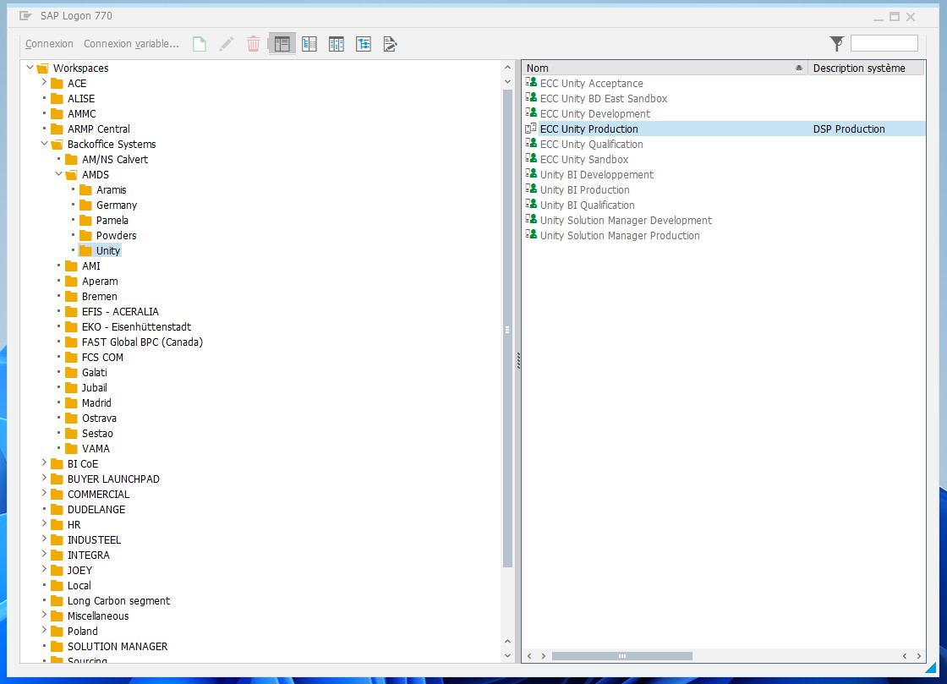
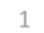
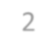
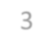
1
Double click
3
2

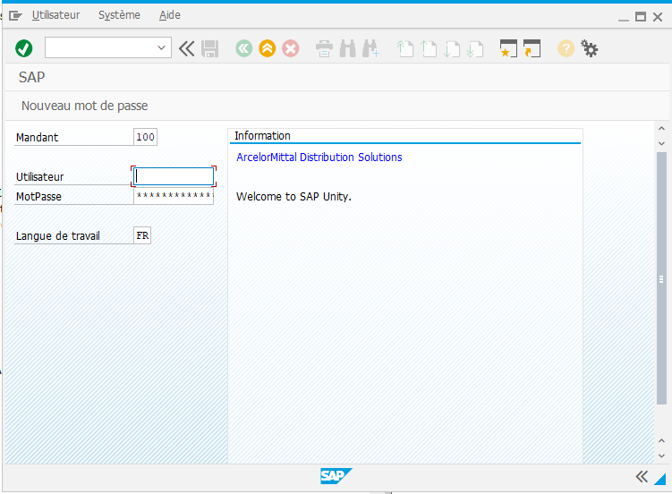
Enter your SAP login and password

Create the dunning notice:

You can go directly to the form by searching for F150, then click on the green button The future has yet to unfold.

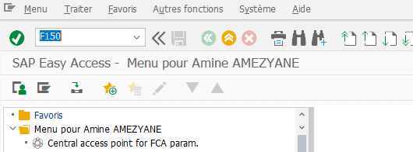
Click to validate

Alternatively, you can access the files indicated.

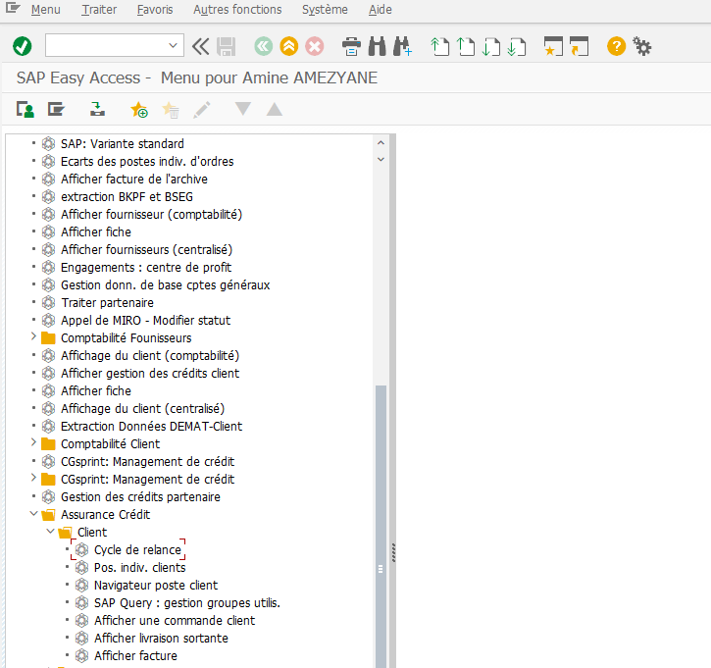

Click on the Credit insurance file Click on the Customer folder Double-click on Dunning cycle

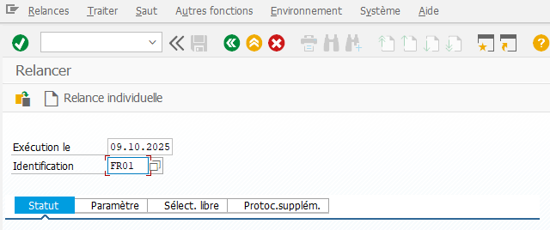
Fill in the dunning form

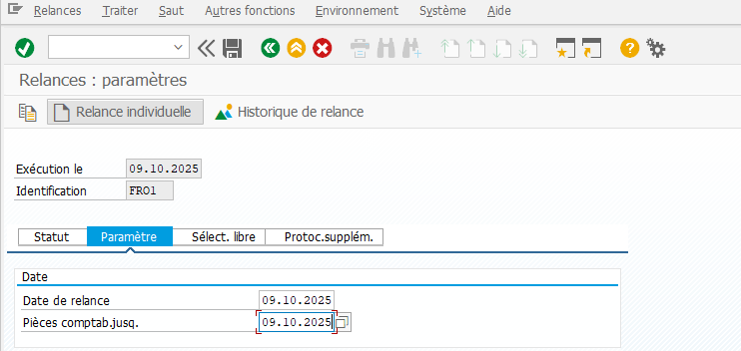
Click on settings
Then enter today's date
FR01

Enter the current date

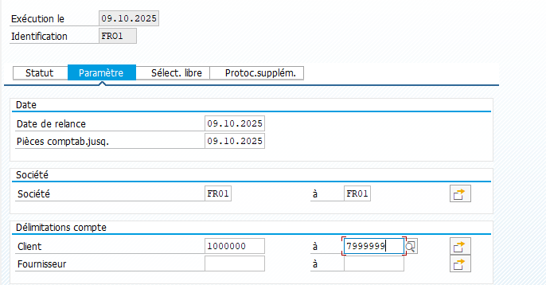
FR01
Fill in the two boxes
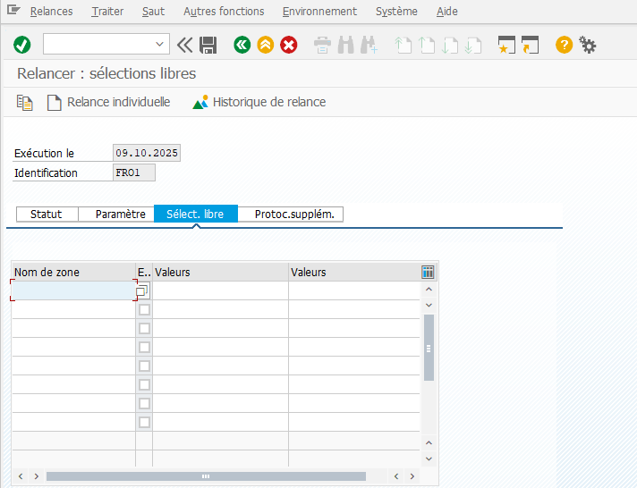
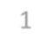
1 Press Free Select.
2
Press the small icon

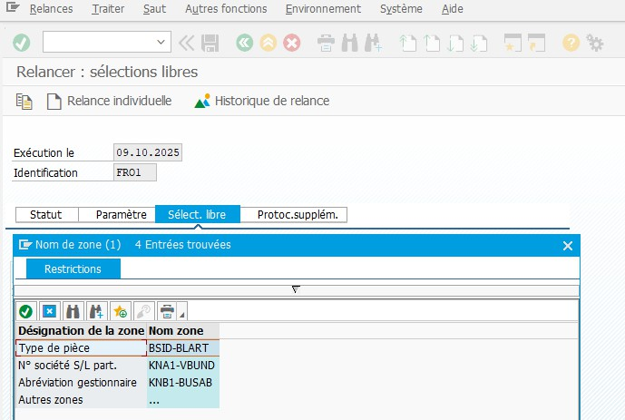

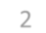
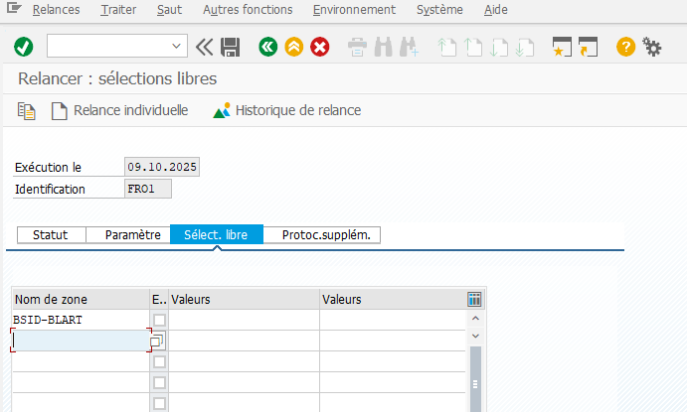
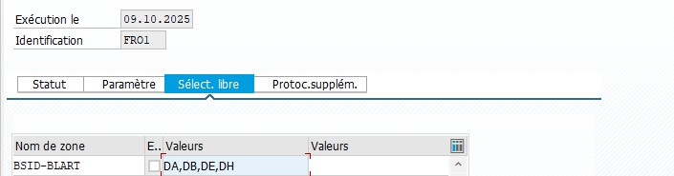

Then validate 2

Select the 1
Part type

For FR01 enter: DA,DB,DE,DH

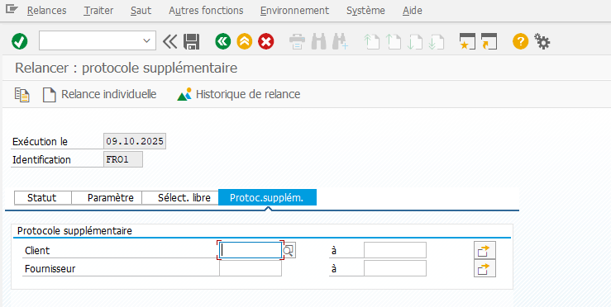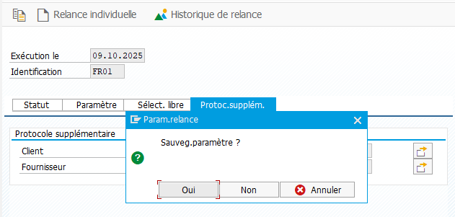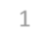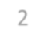
*
Nothing to modify
Nothing to write
1 Click on Status
2 Click on yes

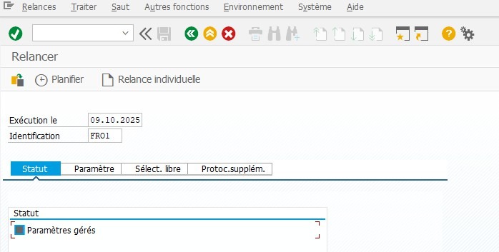
*
Press Schedule
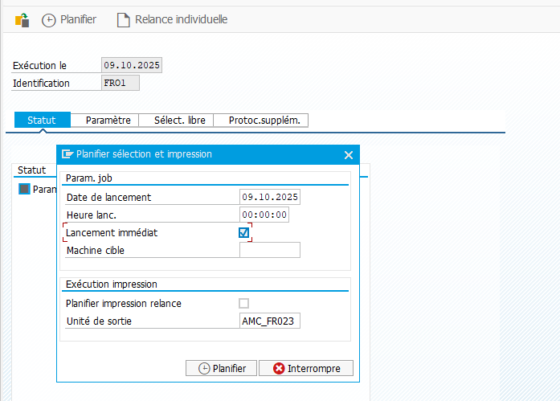
1 Check Immediate launch
2

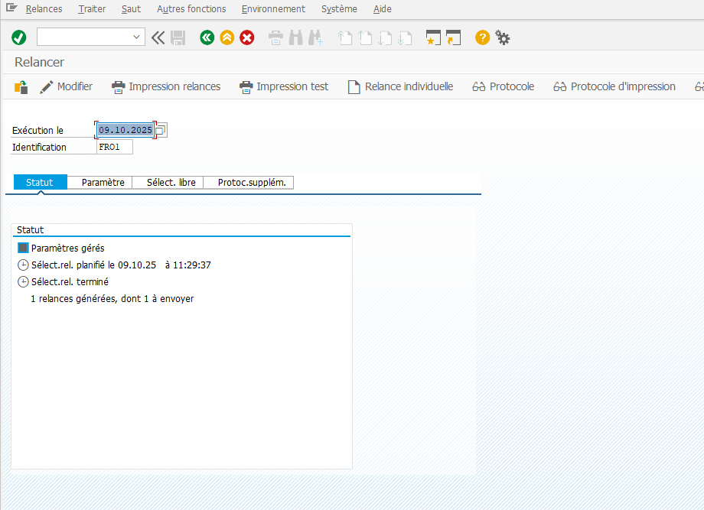
Press ENTER until
these options are displayed

Lunch the printing

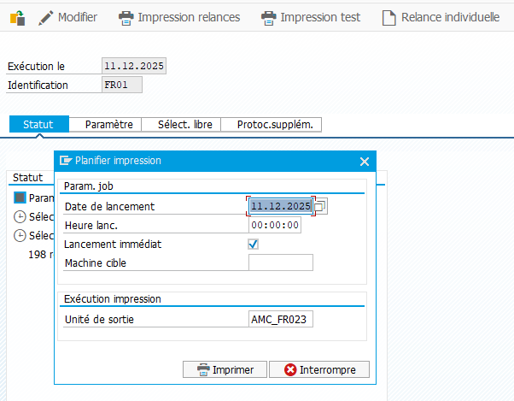

On : 18/11/2025
Procedure validated by : S.HERNANDEZ
